In this report, we are trying to divide the dataset into four different points and we have selected these four different as 4 different period in which we want to evaluate whether or not, the crypto currency is a valuable asset to invest or not. The first period is 2018 and following are the results that has been derived from it.

# Asset Allocation 1

The following is the distribution and percentages that are being followed in different asset allocation 1 strategies of the portfolios.

|  |  |  |  |  |  |
| --- | --- | --- | --- | --- | --- |
|  | **Crypto-monnaies** | **Actions** | **Obligations** | **Or** | **TOTAL** |
| **Conservative** | 0 | 20 | 30 | 50 | 100 |
| **Moderate** | 0 | 40 | 40 | 20 | 100 |
| **Aggressive** | 0 | 65 | 30 | 5 | 100 |

In the first Allocation Strategy the conservative, crypto has been assigned a minimum percentages of funds to be invested and therefore the return of the portfolio can be visualized below:

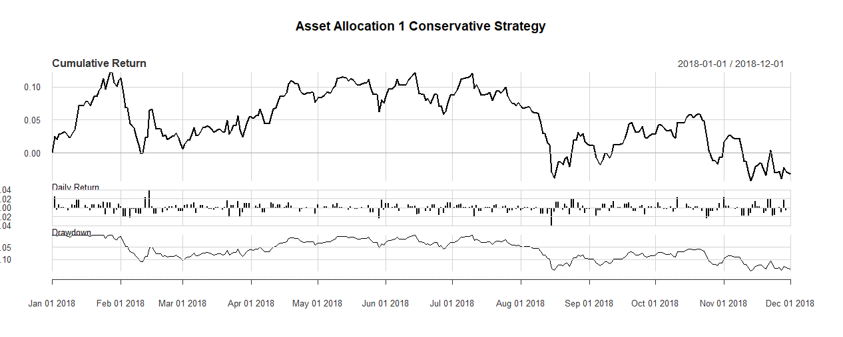

Then we have the results from our moderate strategy and the results are below:

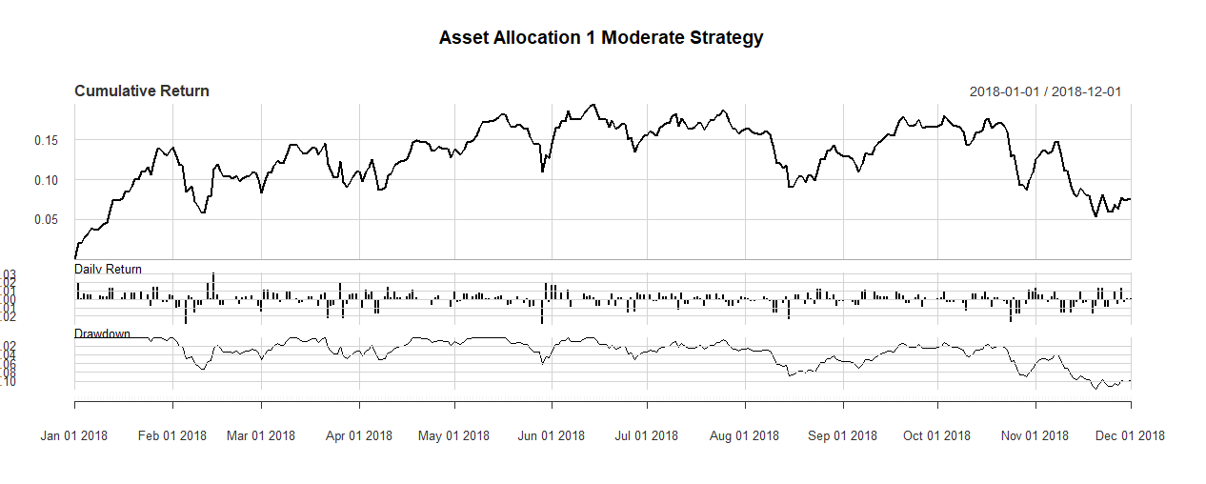

The last is the aggressive strategy in which gold has been assigned minimum percentages of the funds comparatively to the above two strategies:

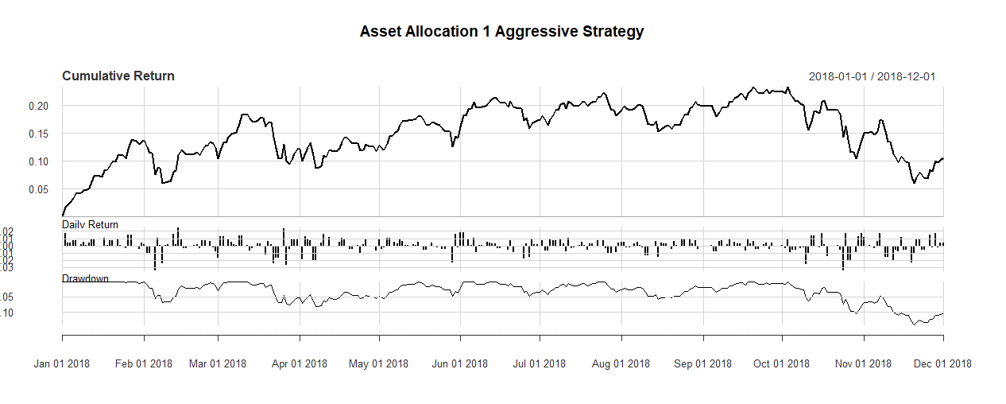

After that all of the returns of these three strategies is being compared in order to see, at this point of time what are the optimized weightages of percentage of funds that must be assigned to each asset; in order to get maximum return and choose the best strategy. The following graph will help us understand all of this:

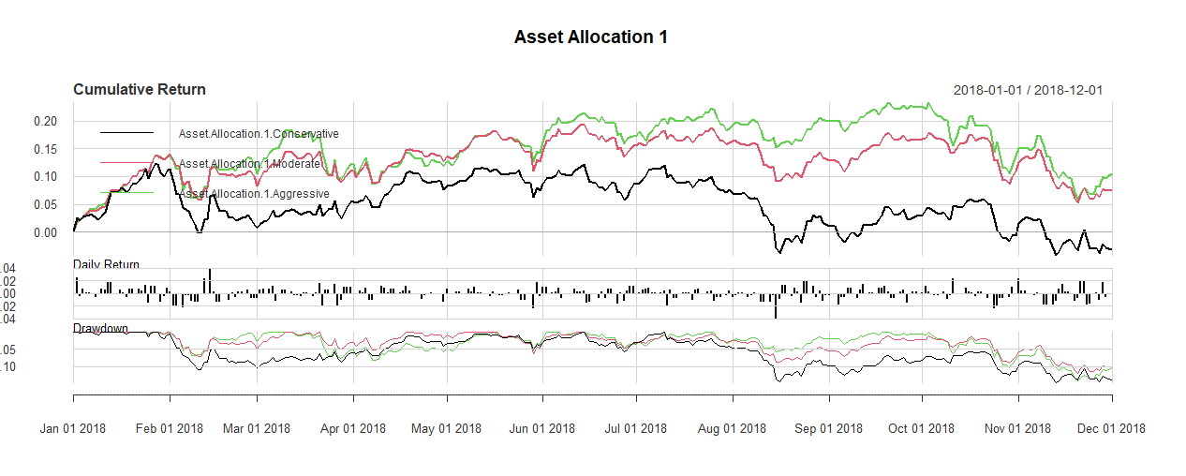

In the above graph, it can be visualized that the conservative strategy is returning minimum return because, in this gold has been assigned a maximum amount of funds. On the other, the aggressive strategy is returning the maximum return but we have a drop down performance of all of the market at the end of 2018 but still Aggressive has been returning the maximum return, the probable reason for this is because gold has been assigned a minimum percentage of funds*. When the return from the gold is low then the return from NASDAQ is high. This is another finding of this study because when price of gold is stable then NASDAQ will be yielding returns.*

Following ratios are calculated for this particular period:

|  |  |  |  |  |  |
| --- | --- | --- | --- | --- | --- |
|  | **Sharpe** | **Sortino** | **VaR** | **Skewness** | **Kurtosis** |
| **Conservative** | -0.1672025 | -0.008486811 | -0.01469308 | -0.08787042 | 2.275385 |
| **Moderate** | 0.4453322 | 0.04237899 | -0.01360522 | -0.5212931 | 2.113125 |
| **Aggressive** | 0.5636575 | 0.05181986 | -0.01545314 | -0.7238944 | 1.896538 |

## Interpretation of the Ratio:

The Sharpe ratio is a measure of return often used to compare the performance of investment managers by making an adjustment for risk. The Sharpe ratio can also help explain whether a portfolio's excess returns are due to smart investment decisions or a result of too much risk. Although one portfolio or fund can enjoy higher returns than its peers, it is only a good investment if those higher returns do not come with an excess of additional risk. The greater a portfolio's Sharpe ratio, the better its risk-adjusted performance. If the analysis results in a negative Sharpe ratio, it either means the risk-free rate is greater than the portfolio’s return, or the portfolio's return is expected to be negative. In either case, a negative Sharpe ratio does not convey any useful meaning. “So for the first strategy, sharp ratio explains that the risk free rate is greater than the return of the portfolio”. Moreover, the second strategy has positive sharp ratio but the sharp less than one is not considered to be good. But the maximum sharp ratio of the portfolio or strategy is considered to be a good ratio and we have seen that amongst the all 3 ratios, maximum sharp ratio exists in the aggressive strategy that means the adjusted risk performance of this strategy is better. Sharpe ratios above 1.0 are generally considered “good," as this would suggest that the portfolio is offering excess returns relative to its volatility. Having said that, investors will often compare the Sharpe ratio of a portfolio relative to its peers. Therefore, a portfolio with a Sharpe ratio of 1.0 might be considered inadequate if the competitors in its peer group have an average Sharpe ratio above 1. On the other hand, we have Sortino ratio that is a variation of the Sharpe ratio is the Sortino ratio, which removes the effects of upward price movements on standard deviation to focus on the distribution of returns that are below the target or required return. A higher Sortino ratio is better than a lower one as it indicates that the portfolio is operating efficiently by not taking on unnecessary risk that is not being rewarded in the form of higher returns. A low, or negative, Sortino ratio may suggest that the investor is not being rewarded for taking on additional risk. Next is Value at Risk (VaR), it is the probability of occurrence for the amount of loss, and the timeframe. The negative VaR means that the portfolio is in the probability of making the profit. Next is skewness that tells us about the direction of outliers. If the skewness is between -0.5 and 0.5, the data are fairly symmetrical. If the skewness is between -1 and – 0.5 or between 0.5 and 1, the data are moderately skewed. If the skewness is less than -1 or greater than 1, the data are highly skewed. And lastly, kurtosis is a measure of whether the data are heavy-tailed or light-tailed relative to a normal distribution. If the kurtosis is greater than 3, then the dataset has heavier tails than a normal distribution (more in the tails). If the kurtosis is less than 3, then the dataset has lighter tails than a normal distribution (less in the tails). For all these, it is not heavier at tail.

# Asset Allocation 2

Following are the graphs of conservation, moderate and aggressive strategy respectively. 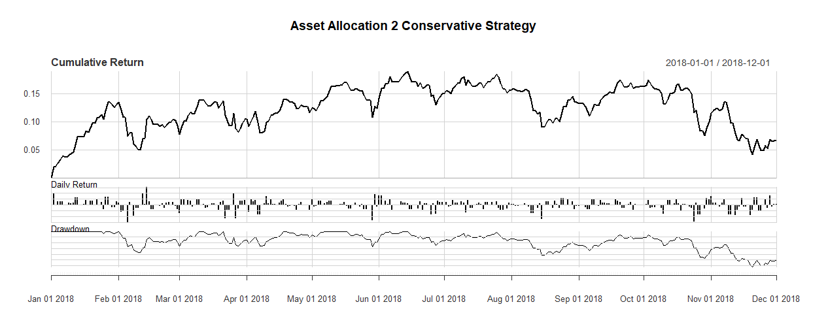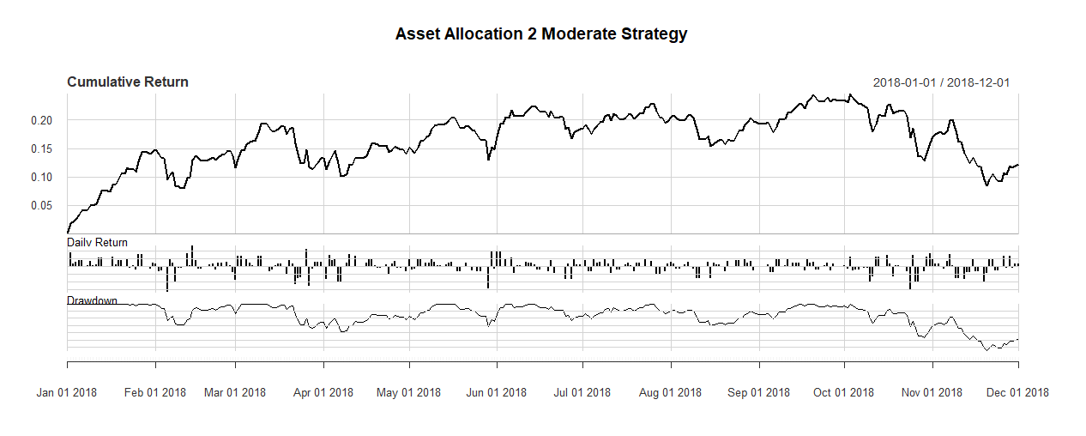

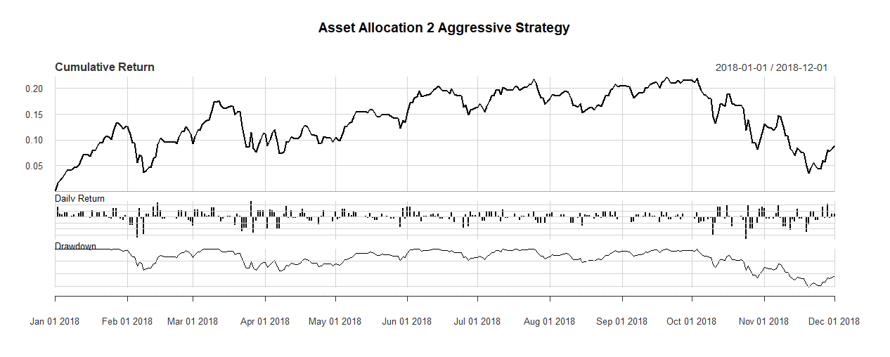

After combining all three of them and comparing the return:

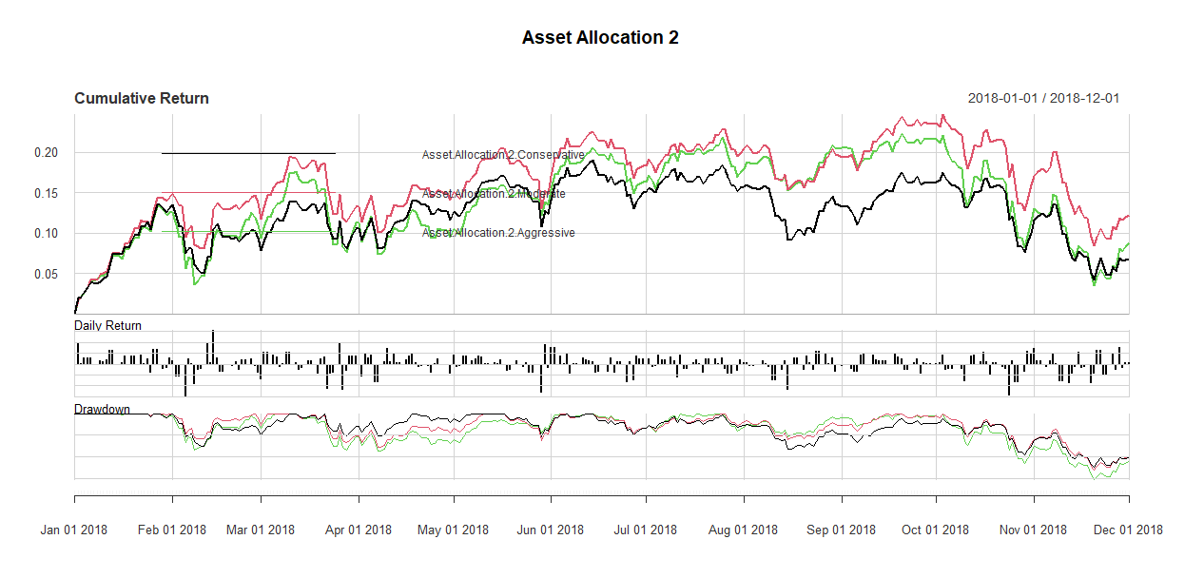

In the above graph, it can be visualized that the conservative strategy is returning minimum return because, in this gold has been assigned a maximum amount of funds. On the other, the aggressive strategy is returning the maximum return but we have a drop down performance of all of the market at the end of 2018 but still Aggressive has been returning the maximum return, the probable reason for this is because gold has been assigned a minimum percentage of funds*. When the return from the gold is low then the return from NASDAQ is high. This is another finding of this study because when price of gold is stable then NASDAQ will be yielding returns.*

Following ratios are derived for asset allocation 2 strategy:

|  |  |  |  |  |  |
| --- | --- | --- | --- | --- | --- |
|  | **Sharpe** | **Sortino** | **VaR** | **Skewness** | **Kurtosis** |
| **Conservative** | 0.3987446 | 0.03849616 | -0.01373312 | -0.5331766 | 1.960937 |
| **Moderate** | 0.6682311 | 0.0600549 | -0.01497908 | -0.7093915 | 1.897027 |
| **Aggressive** | 0.4495833 | 0.04302043 | -0.01624213 | -0.7198936 | 2.012693 |

## Interpretation of the Results

* Sharp ratio is highest in the moderate meaning the adjusted risk performance is better in it and Sortino is also better in moderate that means investor is being rewarded without taking any additional risk.

# Asset Allocation 3

Following are the graphs of conservation, moderate and aggressive strategy respectively.

**Asset Allocation 2**

Following are the graphs of conservation, moderate and aggressive strategy respectively. 



After combining all three of them and comparing the return:



In the above graph, it can be visualized that the conservative strategy is returning minimum return because, in this gold has been assigned a maximum amount of funds. On the other, the aggressive strategy is returning the maximum return but we have a drop down performance of all of the market at the end of 2018 but still Aggressive has been returning the maximum return, the probable reason for this is because gold has been assigned a minimum percentage of funds*. When the return from the gold is low then the return from NASDAQ is high. This is another finding of this study because when price of gold is stable then NASDAQ will be yielding returns.*

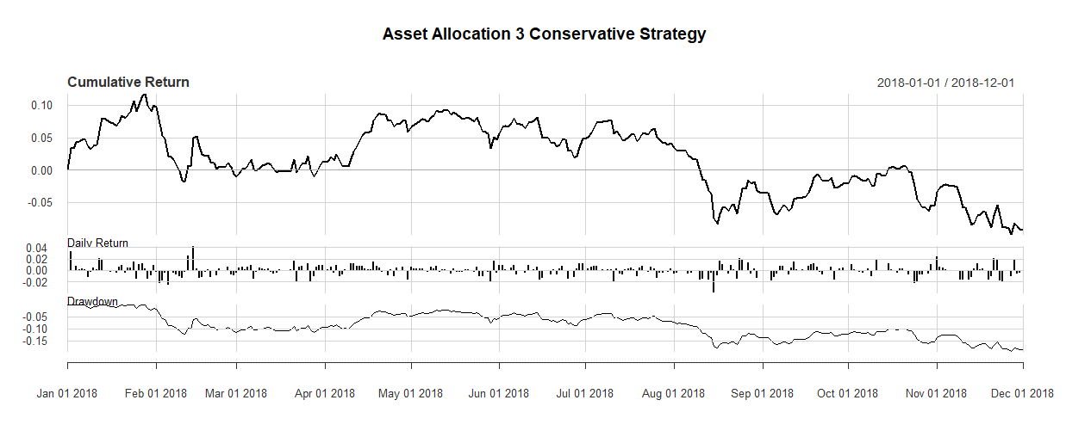

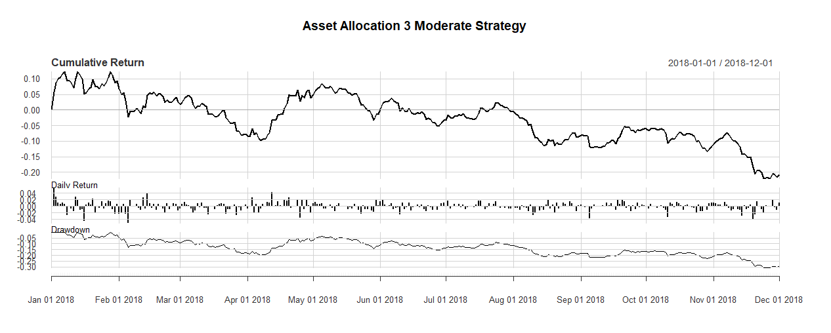

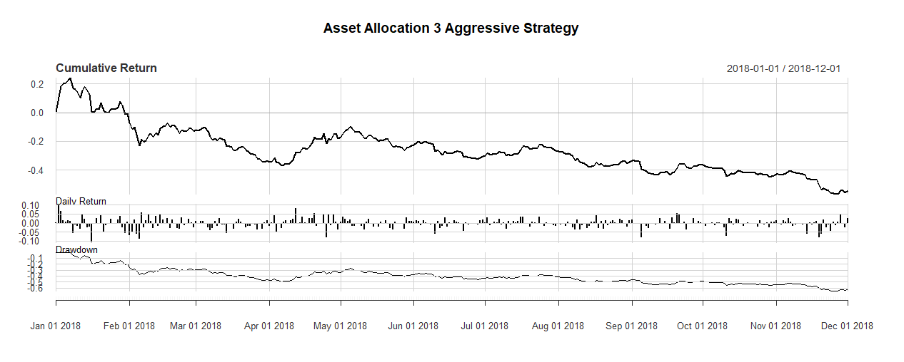

After combining all three of them and comparing the return:

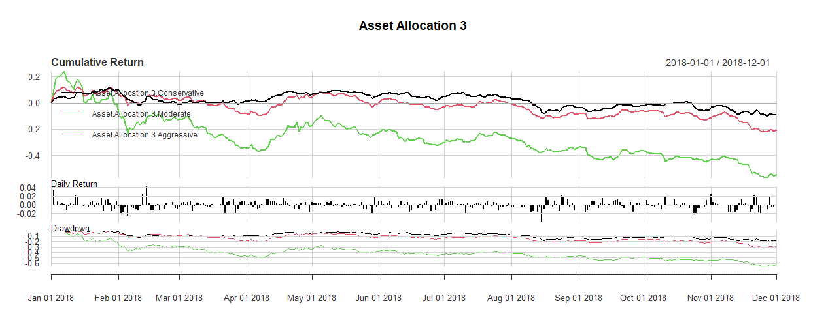

In the above graph, it can be visualized that the conservative strategy is showing good performance and the aggressive is showing the lowest performance in this allocation. The weights are assigned below:

|  |  |  |  |  |  |
| --- | --- | --- | --- | --- | --- |
|  | Crypto | Actions | Obligations | Or | TOTAL |
| **Conservative** | 5 | 15 | 30 | 50 | 100 |
| **Moderate** | 25 | 25 | 40 | 10 | 100 |
| **aggressive** | 60 | 40 | 0 | 0 | 100 |

As we can see the highest proportion of the assets have been assigned to the Crypto currency but it was not able to show good performance and hence we can make an argument that the crypto currency was not giving some good results in 2018. Gold was a valuable asset to be invested in 2018 as conservative was showing good performance.

|  |  |  |  |  |  |
| --- | --- | --- | --- | --- | --- |
|  | **Sharpe** | **Sortino** | **VaR** | **Skewness** | **Kurtosis** |
| **Conservative** | -0.4760071 | -0.03651053 | -0.01482643 | 0.08596267 | 2.389827 |
| **Moderate** | -0.7929399 | -0.06443816 | -0.02130503 | -0.08663697 | 2.393501 |
| **Aggressive** | -1.083586 | -0.1004224 | -0.04536081 | -0.268119 | 2.3831 |

Ratios are not making sense in these portfolios in 2018/

Conservative

|  |  |  |  |
| --- | --- | --- | --- |
| **Index** |  | **Asset Allocation 3** |  |
| Min | 01/01/2018 | Min. | -3.92E-02 |
| 1st | 25/03/2018 | 1st | -4.71E-03 |
| Median | 17/06/2018 | Median | 5.01E-05 |
| Mean | 17/06/2018 | Mean | -2.46E-04 |
| 3rd | 08/09/2018 | 3rd | 4.24E-03 |
| Max. | 01/12/2018 | Max. | 4.28E-02 |

# Asset Allocation 4

The following graphs are obtained in this regard:

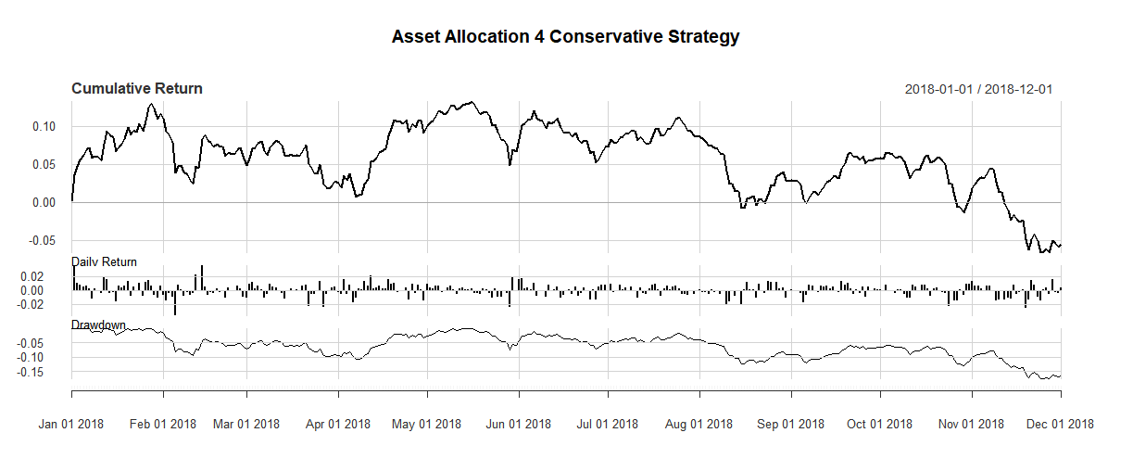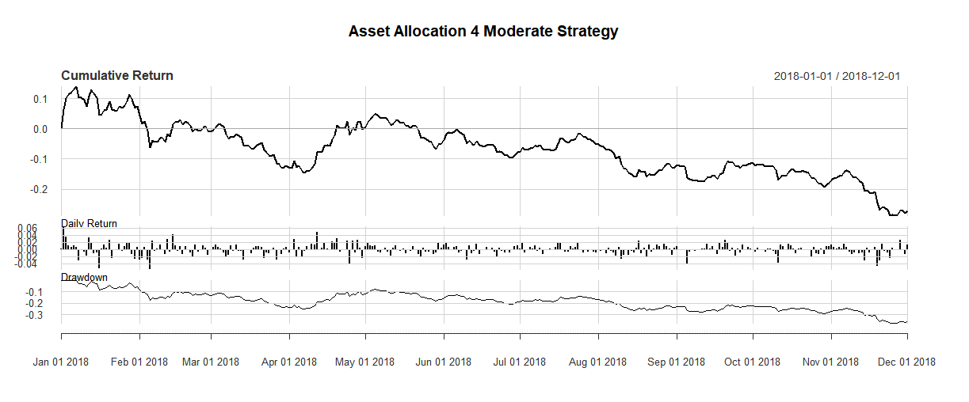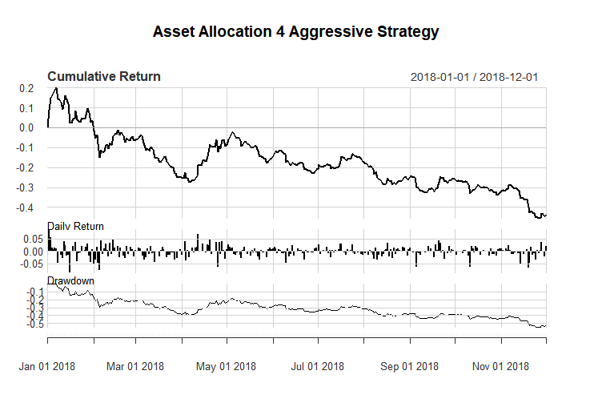

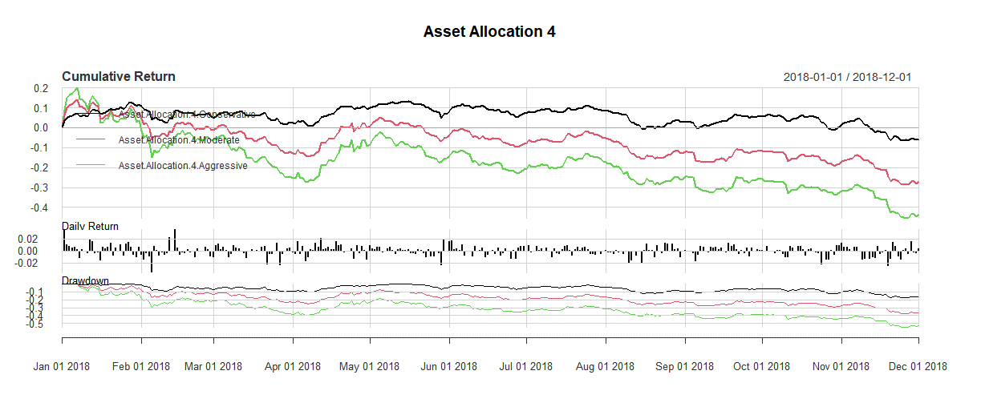

The most return is from the graph of the conservative strategy. Following are the ratios of that asset allocation 4

|  |  |  |  |  |  |
| --- | --- | --- | --- | --- | --- |
|  | **Sharpe** | **Sortino** | **VaR** | **Skewness** | **Kurtosis** |
| **Conservative** | -0.2971363 | -0.02016984 | -0.01445105 | -0.0836268 | 2.210576 |
| **Moderate** | -0.9282024 | -0.07776455 | -0.02430404 | -0.136197 | 2.537583 |
| **Aggressive** | -1.045129 | -0.09181623 | -0.03644181 | -0.2560187 | 2.578865 |

So in 2018, this is not turning out to be a great strategy which means in this period, crypto was not a valuable asset to invest in.